ADVANCED SOFTWARE SERVICES, INC
RAW MATERIALS WAREHOUSE TRANSACTIONS USER MANUAL

Title Page

Table of Contents 1
Function Keys 2
Warehouse Transactions Screen 3
Scan Issues 4
Scan Transfer 5
Scan Justments 6
Posting 7
Enter / Modify Recipts (Browse Recipts) 8
Enter / Modify Recipts (Detail) 9
Enter / Modify Issues 10
Enter / Modify Transfers (Browse Transfers) 11
Enter / Modify Transfers (View Transfers) 12
Enter / Modify Adjustments (Browse Adjustments) 13
Enter / Modify Adjustments (View Adjustments) 14

ADVANCED SOFTWARE SERVICES, INC
FUNCTION KEYS

The following describes the standard function buttons which can be activated with the mouse or the alternate key on your keyboard.

BRWS = The browser folder is a list of records in the file. This is functionally equivalent
to the find option of our standard package.

VIEW = View folder records provides the ability to ADD, CHANGE, DELETE and UPDATE
an individual records.

This effectively replaces the find feature of our legacy Foldware and Corrware products.

SORT BY = The selections at the bottom of the browser which will sort the list in alphabetic order.

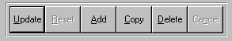

Update = Updating the current record.
Reset = Reset the current record.
Add = Add a record.
Copy = This will copy the existing record.
Delete = Delete the current record displayed on the screen. To delete an individual field, double
click on the field and press the regular delete key on the keyboard.
Cancel = Canceling the information that was entered.
Save = Save the record.


 |  |  |  |  |  |  |  |  |  |  |  |  |  |  |  |  |  |  | First – Takes you to the first record
 |  |  |  |  |  |  |  |  |  |  |  |  |  |  |  |  |  |  | Previous – Takes you back one record at a time
 |  |  |  |  |  |  |  |  |  |  |  |  |  |  |  |  |  |  | Next – Moves forward one record
 | First |  |  | Previous |  |  |  |  | Next |  |  | Last |  |  |  |  |  |  | Last – Last current record
 |  |  |  |  |  |  |  |  |  |  |  |  |  |  |  |  |  |  |  |  | F2 – Search for a record
 |  |  |  |  |  |  |  |  |  |  |  |  |  |  |  |  |  |  |  |  | F3 – List a record
 |  |  |  |  |  |  |  |  |  |  |  |  |  |  |  |  |  |  |  |  | F4 – Add notes to a record
 |  |  |  |  |  |  |  |  |  |  |  |  |  |  |  |  |  |  |  |  | F5 – Misc. fields
F2 |  |  | F3 |  | F4 |  | F5 |  |  | F6 |  |  | F7 |  |  | F8 | F9 | F12 |  |  | F6 – Browse the records
 |  |  |  |  |  |  |  |  |  |  |  |  |  |  |  |  |  |  |  |  | F7– View the records
 |  |  |  |  |  |  |  |  |  |  |  |  |  |  |  |  |  |  |  |  | F8 – Phone Information
 |  |  |  |  |  |  |  |  |  |  |  |  |  |  |  |  |  |  |  |  | F9 – Addressees
 |  |  |  |  |  |  |  |  |  |  |  |  |  |  |  |  |  |  |  |  | F12 – Exit the screen

ADVANCED SOFTWARE SERVICES, INC
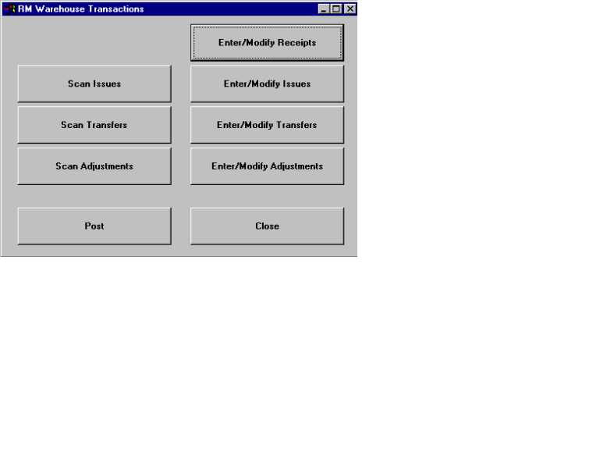WAREHOUSE TRANSACTIONS

ADVANCED SOFTWARE SERVICES, INC
SCAN ISSUES

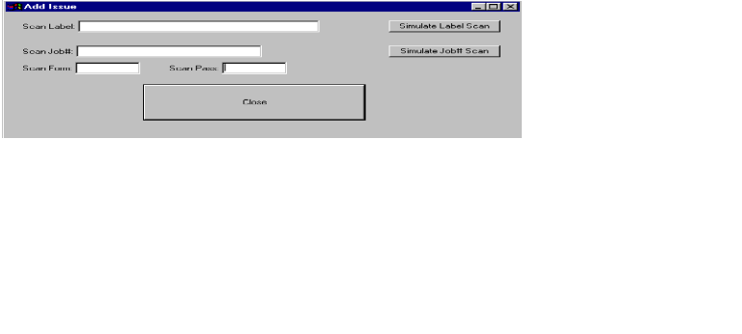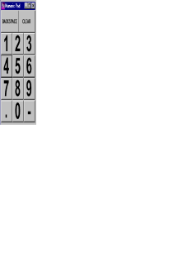

ADVANCED SOFTWARE SERVICES, INC
SCAN TRANSFER
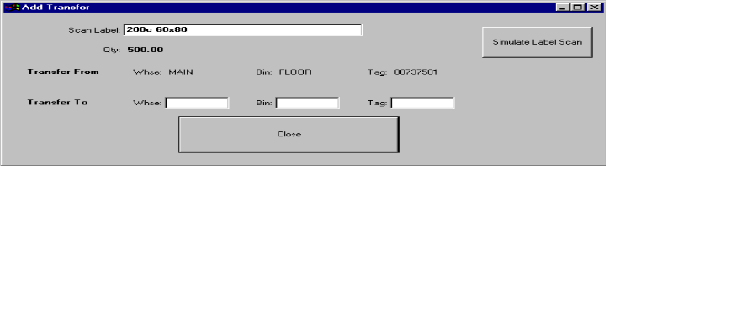

ADVANCED SOFTWARE SERVICES, INC
SCAN JUSTMENTS

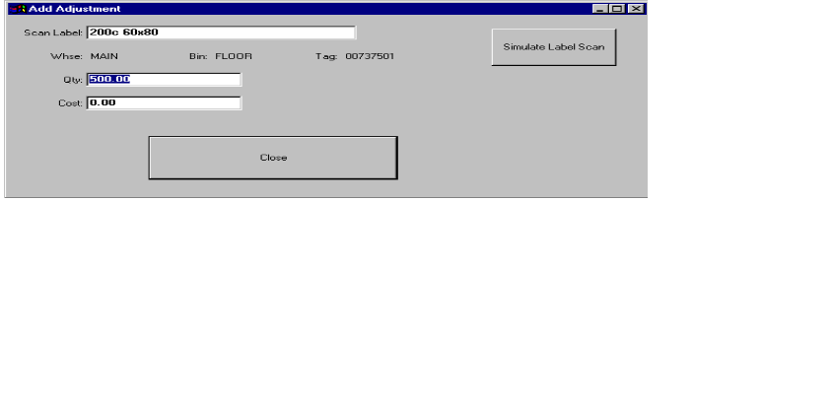

ADVANCED SOFTWARE SERVICES, INC
POSTING

ADVANCED SOFTWARE SERVICES, INC
ENTER / MODIFY RECIPTS – BROWSE RECIPTS

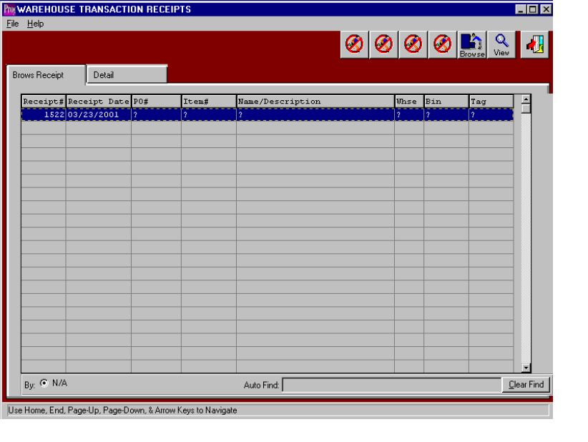

ADVANCED SOFTWARE SERVICES, INC
ENTER / MODIFY RECIPTS - DETAIL
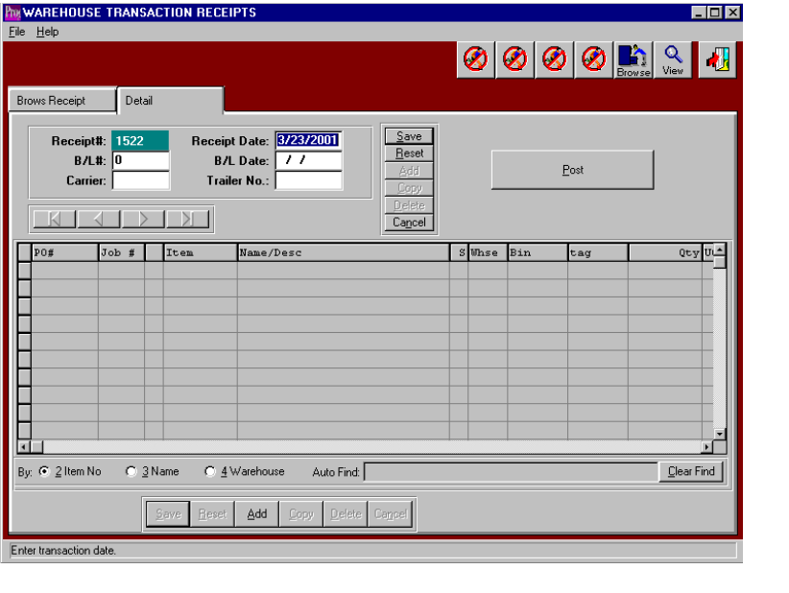

ADVANCED SOFTWARE SERVICES, INC
ENTER / MODIFY ISSUES
ADVANCED SOFTWARE SERVICES, INC
ENTER / MODIFY TRANSFERS – BROWSE TRANSFERS

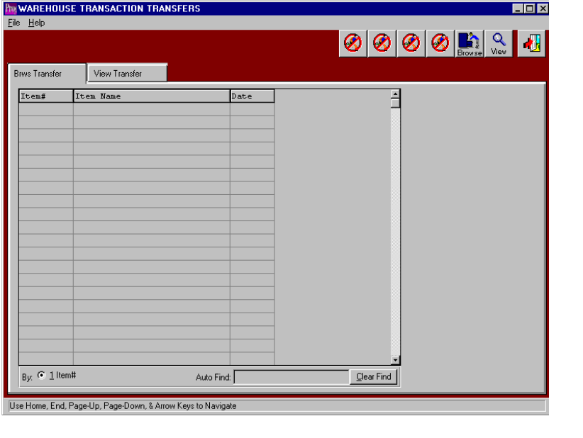

ADVANCED SOFTWARE SERVICES, INC
ENTER / MODIFY TRANSFERS – VIEW TRANSFERS
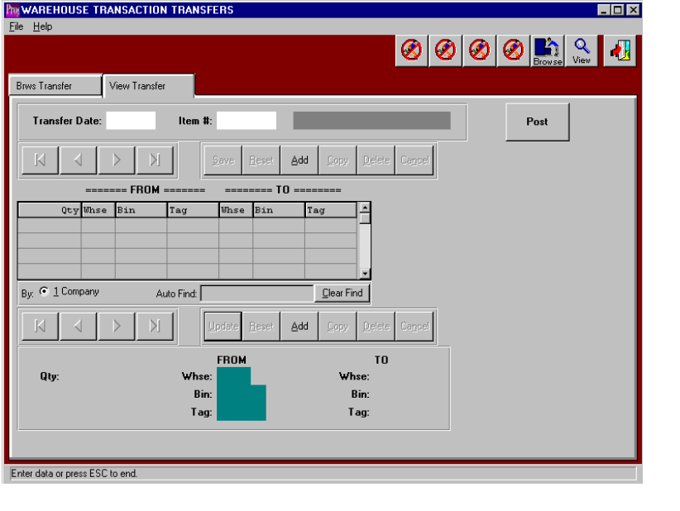

ADVANCED SOFTWARE SERVICES, INC
ENTER / MODIFY ADJUSTMENTS – BROWSE ADJUSTMENTS
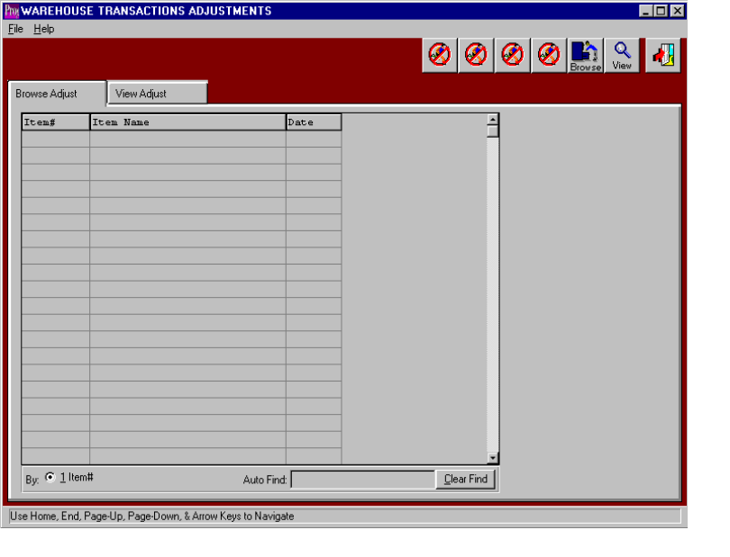

ADVANCED SOFTWARE SERVICES, INC
ENTER / MODIFY ADJUSTMENTS – VIEW ADJUSTMENTS
